# 

Developer Guidelines

How To - Consume Enterprise Logger

Table of Contents

Overview 3

Prerequisites 3

Consuming In .NET Framework Applications (Existing Apps) 4

Consuming In .NET Core Applications 5

# Overview

LogixHealth Enterprise Logger is a reusable component, which are programming libraries developed using .NET Framework (version 4.5) and .NET Core (version 2.1) Framework. This component provides an interface for logging from an application (Consumer) that reduces the huge amount of code/configurations that is required to log. They are designed to help developers for logging

* Exceptions
* Change Data Capture
* User Events

# Prerequisites

* This component has two versions,
* One – Developed using .NET Framework 4.5 (can be consumed by applications developed using .NET Framework(s) version 4.5 and above)
* Two – Developed using .NET Core 2.1 (can be consumed by applications developed using .NET Core 2.1 and above)
* Go to TFS <http://bedtfsapp001:8080/tfs/main> > EnterpriseLoggerService > StableVersion
  + Map this TFS folder $/EnterpriseLoggerService/StableVersion to [C: or D: drive]:\TFS\EnterpriseLoggerService\StableVersion and Get the latest code base
* Go to TFS <http://bedtfsapp001:8080/tfs/main> > EnterpriseLibraries > StableVersion
  + Map this TFS folder $/EnterpriseLibraries/StableVersion to [C: or D: drive]:\TFS\EnterpriseLibraries\StableVersion and Get the latest code base
* Go to your application folder and open your application solution file in Visual Studio 2017
  + Right click on Solution file > click Add > click New Solution Folder > name this folder as “Dependencies”
  + Right click on this Solution Folder “Dependencies” and add the following projects from the location where you have mapped

|  |  |  |
| --- | --- | --- |
| Order | For .NET Framework Application | For .NET Core Application |
| 1 | LogixHealth.EnterpriseLibrary.AppServices.Gateway | LogixHealth.EnterpriseLibrary.AppServices.Gateway.Core |
| 2 | LogixHealth.EnterpriseLogger.Extensions | LogixHealth.EnterpriseLogger.Extensions.Core |
| 3 | LogixHealth.EnterpriseLibrary.Extensions | LogixHealth.EnterpriseLibrar.Extensions.Core |

* + Rebuild/Build these projects and make sure there`s is no reference related errors

# Consuming In .NET Framework Applications (Existing Apps)

To consume in .NET Application (Existing Applications) follow these steps

* After downloading the Enterprise Libraries, Enterprise Logger, and your projects, make sure all the projects are mapped to root folder (as per the TFS Folder structure) as shown below

Example –

|  |  |
| --- | --- |
| Local Workspace Folder Structure | TFS Folder Structure |
|  |  |

* Go to your .NET Application, reference the above (mentioned in prerequisites) projects as Project Reference
* Go to your .NET Application (Existing Apps) Setting WEB CONFIG file and add these configuration keys

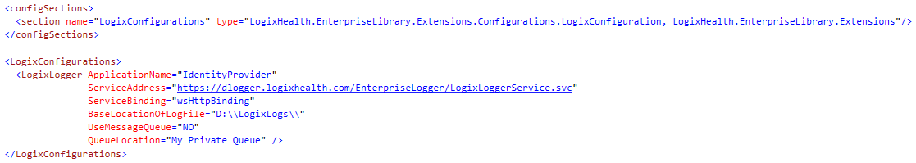

* Go to your application start event or wherever the application is initializing and add the following code



* Follow the below steps to log the exceptions wherever you`re handling

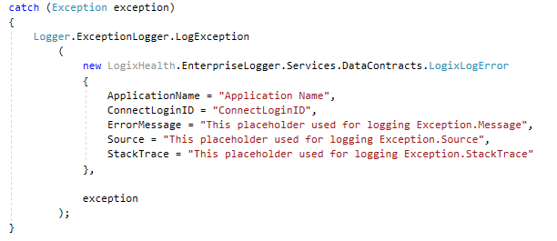

# Consuming In .NET Core Applications

To consume in .NET Core application follow these steps

* After downloading the Enterprise Libraries, Enterprise Logger, and your projects, make sure all the projects are mapped to root folder (as per the TFS Folder structure) as shown below

Example –

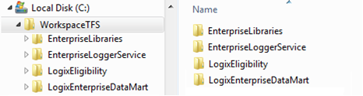

* Go to your .NET Core Application, reference the above mentioned projects as Project Reference
* Go to your .NET Core Application Setting JSON file and add these configuration keys

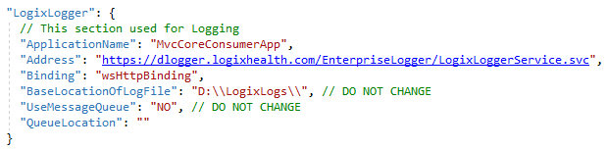

* Go to your .NET Core Application, open STARTUP.CS file > ConfigureServices method and add these code

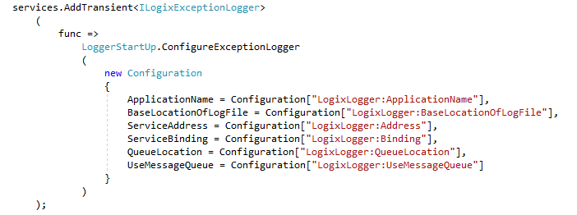

* Go to your Controllers and inject the ILOGIXEXCEPTIONLOGGER in the constructor as shown below

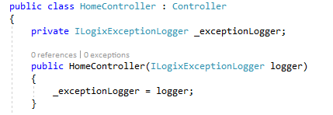

* Follow the below steps to log the exceptions wherever you`re handling

